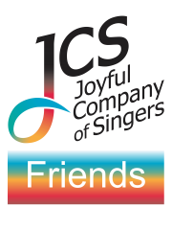
To Gift Aid your donation as a Friend of the JCS,
please complete this form
and either:

- attach it to an email to:
friends@jcos.co.uk

or
- hand a completed printed copy
to our Friends desk at a JCS performance

Name: …
Address: …
Postcode: …

GIFT AID

Using Gift Aid makes your donation worth 25% more. Please put ‘X’ against your chosen option below:

… Yes, please treat all my donations from the date below and until further notice as Gift Aid. I confirm I have paid or will pay an amount of income tax and/or capital gains tax for each tax year (6 April to 5 April) that is at least equal to the tax that all the charities or Community Amateur Sports Clubs that I donate to will reclaim on my gifts for that tax year.

… No, I do not pay income tax or capital gains tax in the UK or I prefer not to make a Gift Aid Declaration.

Signature: ... Date: ...
By signing this form, I confirm my Gift Aid declaration and accept that my personal data will be kept secure and made available only to authorised JCS personnel according to the JCS Privacy Policy available at
www.jcos.co.uk/privacy-policy.

Thank you for choosing to become a Friend!

