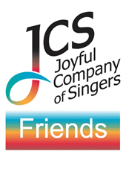
The Friends of JCS

The coronavirus pandemic has affected everyone and hit amateur singing particularly. We send a huge ‘thank you’ to all our Friends who have continued to support the choir through this very difficult period.
Friends support us both with donations and as audience members. Friends also support our Youth Fund which provides a bursary for a young conductor to work with us and be coached by our founder-director, Peter Broadbent, one of Britain’s leading choral conductors. Our latest Junior Conducting Fellow, Olivia Tait, will conduct some of tonight’s programme.
We warmly invite new Friends to enjoy the Scheme’s improved benefits for all who donate regularly a minimum £5 monthly/£60 annually – larger amounts are most welcome, of course!

Friends’ benefits include:

- 10% discount on unlimited tickets to JCS own-promotion events
- Pre-concert ‘Meet the Musicians’ talks and complimentary Friends’ receptions at all JCS own-promotion concerts
- Participation in JCS ‘Come and Sing’ days at discounted rates
- A password-protected Friends page on the JCS website offering choir news and free downloads of JCS copyright audio recordings.
- A free copy of our ‘Sing Joyfully’ CD
- Discounts on new JCS recordings and archive CDs from our stocks

To join the Friends, please use the contact form on www.jcos.co.uk or send an email to friends@jcos.co.uk.

Our next performances:

Monday 2nd May at 3pm
‘Stars and Bars! - Music from the American Songbook’
All Saints Church, Falmouth, Cornwall, TR11 3PN

Tuesday 10th May at 7pm
‘Symphonies for Voices’
St Gabriel’s Church, Pimlico, London SW1V 2AD

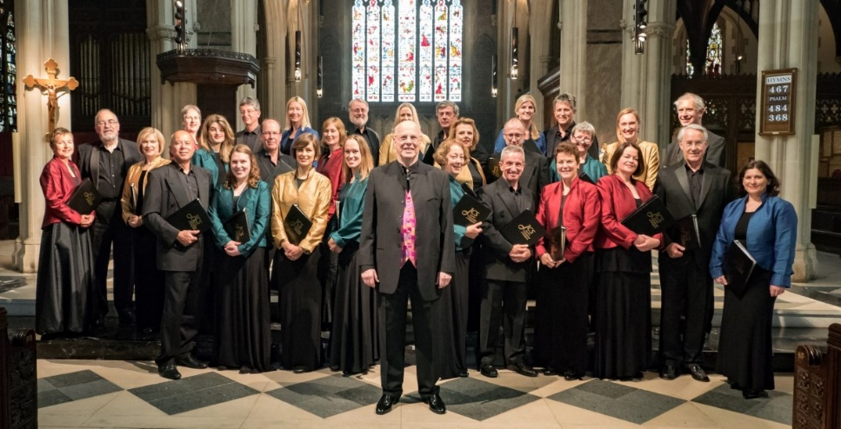

Website www.jcos.co.uk
Facebook @JoyfulCompanyofSingers
Twitter @JoyfulCompany
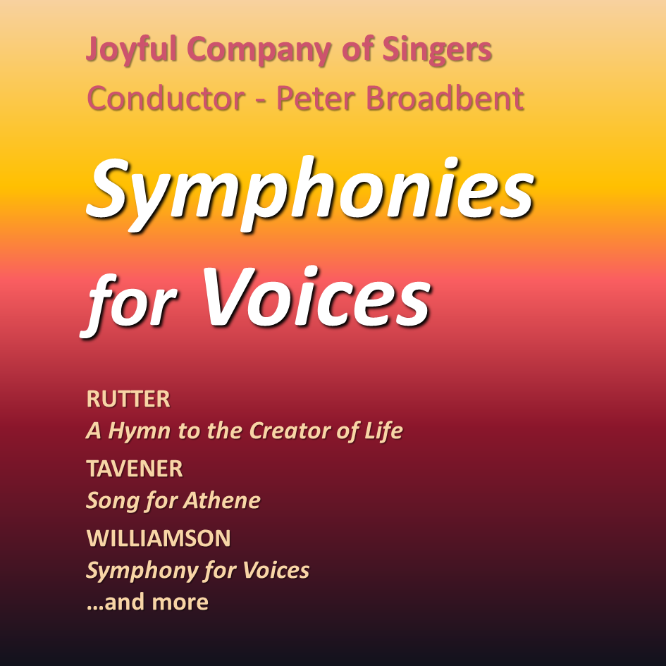

30th April 2022

St. Endellion Church, Cornwall

PROGRAMME

Hymn to the Creator of Light | John Rutter
O Radiant Dawn | Sir James MacMillan
Song for Athene | Sir John Tavener
Conducted by Olivia Tait
Symphony for Voices (to poems by James McCauley) |  | Malcolm Williamson
Invocation (Lorna Perry Mezzo-Soprano); Terra Australis; Jesus; Envoi; New Guinea
INTERVAL
An Amateur of Fashion  The Quacks (English Eccentrics Choral Suite) |  |  | Malcolm Williamson
Love Walked Right In | George & Ira Gershwin arr. Antony Saunders
Fascinating Rhythm
Conducted by Olivia Tait
My Funny Valentine | Rodgers & Hart arr. Howard Moody
Soloists: Olivia Maffett, Andy Mackinder
Blue Moon | Rodgers & Hart arr. Blackwell
Oblivion | Astor Piazzolla arr. Escalada/Broadbent
Clarinet: Sally Donegani
Bumba meu boi | Trad. arr. Carlos Alberto Pintos Fonseca
Les Feuilles d’Automne | Joseph Kosma arr. Andrew Carter

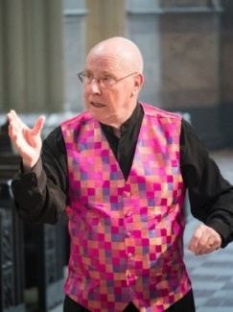
Peter Broadbent, the founder conductor of the Joyful Company of Singers, is one of Britain’s leading choral conductors. He has conducted the London Mozart Players, Divertimenti Chamber Orchestra, the English Chamber Orchestra, the City of London Sinfonia, the Royal Philharmonic Orchestra, the Southern Sinfonia, the Guildford Philharmonic Orchestra, Apollo Voices and the BBC Singers, broadcasting frequently on BBC Radio 3 and Classic FM.

Guest engagements outside the UK include concerts with the Debrecen Philharmonic Orchestra and Kodály Chorus in Debrecen (Hungary), a broadcast concert with the National Chamber Choir in Dublin and a European tour with the World Youth Choir.

Peter Broadbent gives workshops and master classes throughout Europe and was the first Director of Training for the Association of British Choral Directors. In 2007 he was presented with the Pro Cultura Hungarica Award by the Hungarian Ministry of Culture for his services to Anglo-Hungarian musical relations, and in 2017 was presented with the Knight’s Cross of the Hungarian Order of Merit. He was awarded an MBE in the 2022 New Years Honours for service to music.

Olivia Tait is a London based conductor, recently having graduated with a distinction in her MA Choral Conducting from the Royal Academy of Music, where she held an entrance scholarship and studied under Patrick Russill.

As well as her Junior Fellowship with the Joyful Company of Singers, Olivia is also the St Martin-in-the-Fields Conducting Fellow, where she works with the St Martin’s Choral Scholars and Chamber Choir in conducting weekly services. She is also the Genesis Sixteen Conducting Scholar 2020/21 where she receives tutoring from Harry Christophers and Eamonn Dougan in conducting the Genesis Sixteen Choir. Olivia recently received a place on the Jette Parker Women Conductors Course, where she conducted scenes from Verdi’s La Traviata with the City of London Sinfonia at the Royal Opera House under the tuition of Sian Edwards, Alice Farnham and Jessica Cottis and went on to deputise as chorus master for Opera Holland Park’s production of Janacek’s The Cunning Little Vixen.

She also participated in the DIMA International Choral Conducting Competition where she was a finalist and received the Gheorge Dima Special Prize.

***

One of Europe’s most prominent chamber choirs, the Joyful Company of Singers is known for its virtuosity and intensity of spirit, as well as for an astoundingly wide repertoire, ranging from the 16th Century to the present day, including many first performances. Formed in 1988 by conductor Peter Broadbent, the choir first came to prominence when it won the Sainsbury’s Choir of the Year competition in 1990. Since then it has maintained its profile in the music world, winning an impressive list of national and international competitions leading to many invitations to perform. Concert appearances include most of the leading UK festivals and regular concert tours in Europe, broadcasting in many countries as well as on BBC and Classic FM. A discography of over 25 CDs includes Rachmaninov’s All-night Vigil on Nimbus: ‘beautifully characterized and shaped by Peter Broadbent’ (International Record Review).

The JCS has also instituted a Youth Fund to encourage the development of young choral conductors, singers and composers. The first composition competition was won by young Australian composer Chris Williams and in 2016 the JCS co-commissioned the major work Dancing Star from Toby Young. In addition, we now welcome Olivia Tait as our fifth funded Junior Conducting Fellow to work with the choir.

